
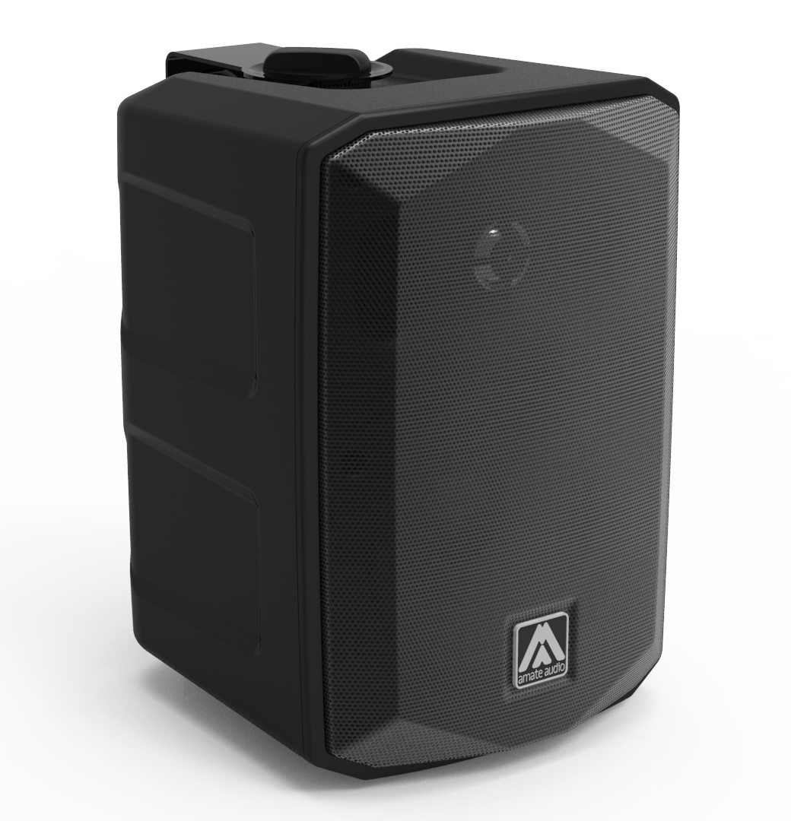
Architectural and engineering specifications

G7

• The 2-way full range passive loudspeaker system shall have one direct radiating carbon fibre cone ferrite magnet 6.5-inch low frequency transducer and one 1-inch voice coil diameter, titanium diaphragm neodymium magnet tweeter. Low frequency transducer shall be rated at a nominal impedance of 16 ohms. High frequency transducer shall be rated at a nominal impedance of 8 ohms.

• The usable bandwidth shall be 60Hz to 20kHz (-10dB).

• The system’s horizontal coverage shall be 80º, with vertical coverage of 80º.

• SPL, measured at 1W and 1m under free field conditions shall be 91 dB. Maximum SPL continuous, measured at 1m under free field conditions shall be 112 dB. Maximum SPL peak, measured at 1m under free field conditions shall be 115 dB.

• Maximum continuous musical program shall be 120W.

• Enclosure shall be bass-reflex type.

• Enclosure cabinet construction shall consist of technical ABS. Dimensions shall be 209 mm (8,2 inch) wide, 296 mm (11,6 inch) high, 218 mm (8,6 inch) deep. Enclosure weight shall be 3,6 Kg.

• The front enclosure shall be protected by an aluminium grille.

• The enclosure shall include four M4 points on the back side for rigging and shall be used in conjunction with SP-6N accessory.

• The enclosure shall include two M6 points on the top and bottom side for rigging and shall be used in conjunction with included “U” bracket.

• Electrical connections shall be made via two pushing terminals with the following configuration: positive (red), negative (black).

• The system shall include an internal passive crossover.

• The loudspeaker system shall be the Amate Audio® G7.
• The rigging accessories shall be the Amate Audio® SP-6N.

