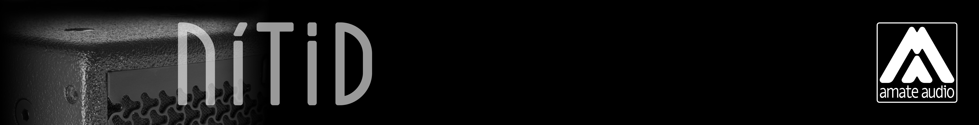
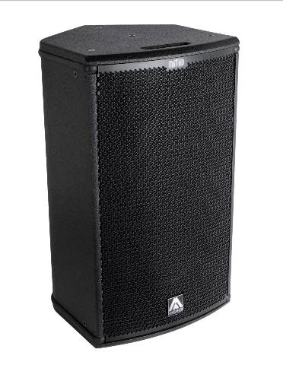
Architectural and engineering specifications

N12A6

• The 2-way full range active loudspeaker system shall have one direct radiating ferrite magnet 12-inch low frequency transducer and one 1.4-inch voice coil diameter, PETP diaphragm ferrite magnet compression driver loaded onto an asymmetrical rotational horn. Low frequency transducer shall be rated at a nominal impedance of 4 ohm. High frequency transducer shall be rated at a nominal impedance of 8 ohm.

• The usable bandwidth shall be 52Hz to 19kHz (-10dB).

• The system’s horizontal coverage shall be 50º to 100º, with vertical coverage of 55º.

• Maximum SPL continuous, measured at 1m under free field conditions shall be 126 dB. Maximum SPL peak, measured at 1m under free field conditions shall be 129 dB.

• Enclosure shall be bass-reflex type with two half-round ducts.

• Enclosure cabinet construction shall consist of birch plywood. Dimensions shall be 360 mm (14,2 inch) wide, 623 mm (24,5 inch) high, 390 mm (15,4 inch) deep. Enclosure weight shall be 20 Kg.

• Enclosure cabinet finish shall consist of black matt high-resistance Polyurea® paint.

• The front enclosure shall be protected by a 2mm steel grille with acoustically transparent technical mesh. The grille shall be secured via screws to keep it in place when facing the cabinet downwards.
• The enclosure shall include M8 points and internal hardware for rigging and shall be used in conjunction with dedicated rigging accessories. Rigging accessories shall be affixed with special crop resistant screws.

• The cabinet shall feature a 35mm (1,38 inch) diameter pole mount socket mounted on the bottom side, for a standard tripod.

• The amplifier shall be built inside the cabinet, consisting of two channels, with a total power of 500W/4Ohm for the low frequency channel and 100W/8Ohm for the high frequency channel. The amplifier shall be 3rd Generation Class D with switching power supply. The amplifier’s power supply shall automatically select the input voltage.

• The audio input shall be electronically balanced with a 20kOhm impedance. Connectors shall be XLR type (one female for input and one male for linking). Mains supply shall be through PowerCon (input and link).

• The DSP controller shall be built inside the cabinet and integrated to the power amplifier. The internal DSP architecture shall be 48-bit fixed point, featuring 2nd order IIR biquad filters. Analog-to-Digital converters shall have more than 102dB signal-to-noise ratio, 24-bit word size and shall work at 48kHz sampling rate. The controller shall contain several factory presets that shall be visible and selectable by the user at the cabinet’s rear panel (with built-in LCD and keypad). The gain shall also be adjustable from the keypad. The DSP shall incorporate a up to 40-meter (118ms) delay line.

• The system shall be capable of monitoring the following parameters: input level, output level per channel, output stage temperature (in the LCD), clip limiter activation and amplifier protection status (with LEDs).

• The amplifier shall be capable of switching itself automatically on a low power consumption mode, depending on the presence of audio signal at the input. The low power consumption mode shall be user selected and the power consumption under this circumstance shall not exceed 5 Watt. The amplifier shall be able to reactivate itself to normal operation after detecting audio signal at its input.
• The loudspeaker system shall be the Amate Audio® NITID N12A6.
• The rigging accessories shall be the Amate Audio® ACR-M8, U-BL, HR-S, HR-S/GT, SP-WHR, RB-S, RB-S/GT.
April 2024

