
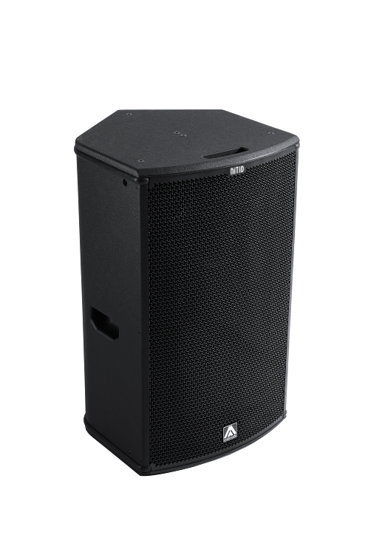
Architectural and engineering specifications

N15P

• The 2-way full range passive loudspeaker system shall have one direct radiating neodymium magnet 15-inch low frequency transducer and one 2,5-inch voice coil diameter, titanium diaphragm neodymium magnet compression driver loaded onto a 60º x 50º dispersion horn. Low frequency transducer shall be rated at a nominal impedance of 8 ohms. High frequency transducer shall be rated at a nominal impedance of 8 ohms.

• The usable bandwidth shall be 50Hz to 18kHz (-10dB).

• The system’s horizontal coverage shall be 60º, with vertical coverage of 50º. The user shall be able to rotate the horn in four directions as required by the application

• SPL, measured at 1W and 1m under free field conditions shall be 100 dB. Maximum SPL continuous, measured at 1m under free field conditions shall be 130 dB. Maximum SPL peak, measured at 1m under free field conditions shall be 133 dB.

• Maximum continuous musical program shall be 1200W.

• Enclosure shall be bass-reflex type with two half-round ducts.

• Enclosure cabinet construction shall consist of birch plywood. Dimensions shall be 460 mm (18,1 inch) wide, 753 mm (29,6 inch) high, 487 mm (19,2 inch) deep. Enclosure weight shall be 26,5 Kg.

• Enclosure cabinet finish shall consist of black matt high-resistance Polyurea® paint.

• The front enclosure shall be protected by a 2mm steel grille with acoustically transparent technical mesh. The grille shall be secured via screws to keep it in place when facing the cabinet downwards.

• The enclosure shall include M8 points and internal hardware for rigging and shall be used in conjunction with dedicated rigging accessories. Rigging accessories shall be affixed with special crop resistant screws.

• The cabinet shall feature a 35mm (1,38 inch) diameter pole mount socket mounted on the bottom side, for a standard tripod.

• Electrical connections shall be made via one of the two 4-pole NL4MPR Speakon connectors with the following configuration: +1/-1 signal input, +2/-2 disconnected.

• The system shall include an internal passive crossover.

• The loudspeaker system shall be the Amate Audio® NITID N15P.
• The rigging accessories shall be the Amate Audio® ACR-M8, U-BL, HR-L, HR-L/GT, SP-WHR.

February 2022

