

Architectural and engineering specifications

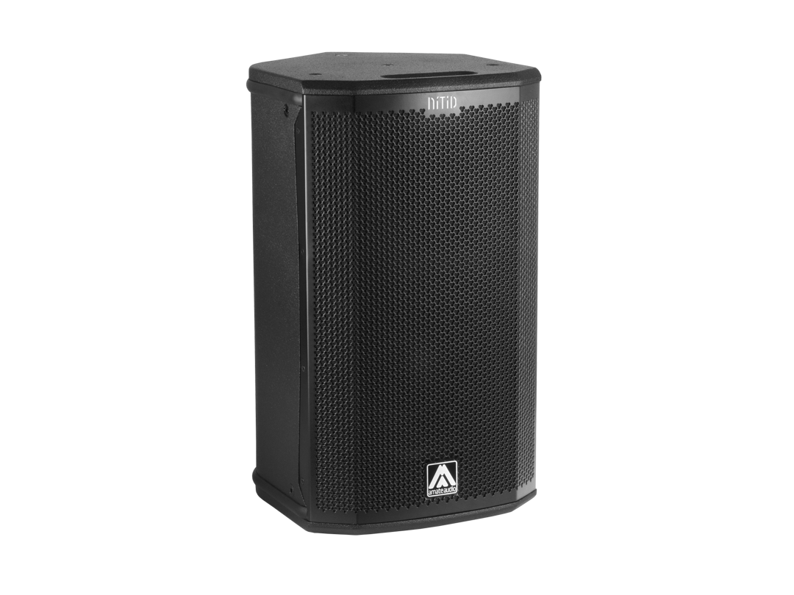
S10P

• The 2-way full range passive loudspeaker system shall have one direct radiating, 2-inch voice coil, 10-inch ferrite magnet low frequency transducer and one 1.4-inch voice coil diameter, polyester diaphragm driver loaded onto an asymmetrical rotational horn. Low frequency transducer shall be rated at a nominal impedance of 8 ohms. High frequency transducer shall be rated at a nominal impedance of 16 ohms.

• The usable bandwidth shall be 55Hz to 19kHz (-10dB).

• The system’s horizontal coverage shall be 50º to 100º, with vertical coverage of 55º.

• SPL, measured at 1W and 1m under free field conditions shall be 96 dB. Maximum SPL continuous, measured at 1m under free field conditions shall be 123 dB. Maximum SPL peak, measured at 1m under free field conditions shall be 126 dB.

• Maximum continuous musical program shall be 500W.

• Enclosure shall be bass-reflex type with two half-round ducts.

• Enclosure cabinet construction shall consist of birch plywood. Dimensions shall be 313 mm (12.3 inch) wide, 543 mm (21.4 inch) high, 358 mm (14.1 inch) deep. Enclosure weight shall be 15.3 Kg.

• Enclosure cabinet finish shall consist of black matt high-resistance Polyurea® paint.

• The front enclosure shall be protected by a 1.5mm steel grille with acoustically transparent technical mesh. The grille shall be secured via screws to keep it in place when facing the cabinet downwards.

• The enclosure shall include M8 points and internal hardware for rigging and shall be used in conjunction with dedicated rigging accessories. Rigging accessories shall be affixed with special crop resistant screws.

• The cabinet shall feature a 35mm (1,38 inch) diameter pole mount socket mounted on the bottom side, for a standard tripod.

• Electrical connections shall be made via one of the two 4-pole NL4MP Speakon connectors with the following configuration: +1/-1 signal input, +2/-2 disconnected.

• The system shall include an internal passive crossover.

• The loudspeaker system shall be the Amate Audio® NITID S10P.
• The rigging accessories shall be the Amate Audio® ACR-M8, HR-LU, HR-LU/GT, UB-L, SP-WHR, RB-S, RB-S/GT.

April 2024

