

Architectural and engineering specifications
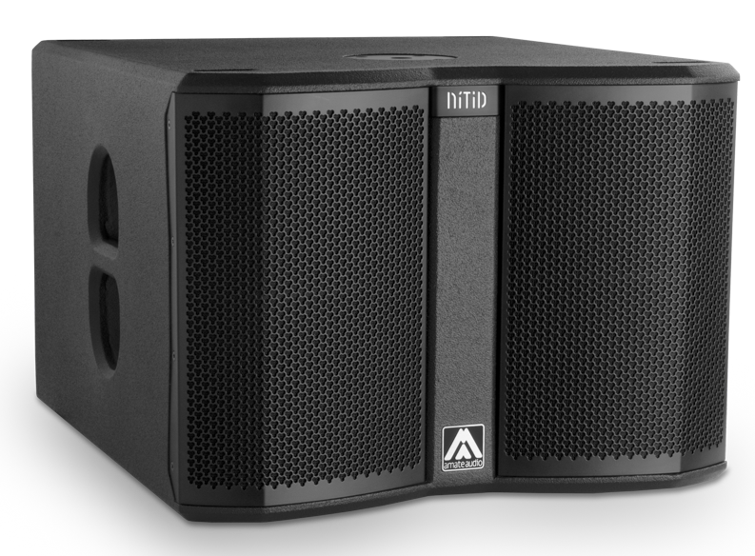
S12WP

• The system shall consist of a passive subwoofer enclosure. The enclosure shall feature a 3-inch voice coil, ferrite magnet, 12-inch loudspeaker component, loaded in a band-pass tuned enclosure. Low frequency transducer shall be rated at a nominal impedance of 8 ohms.

• The usable bandwidth (using an external DSP) shall be 38Hz to 130Hz (-10dB).

• SPL, measured at 1W and 1m under free field conditions shall be 96 dB.

• Maximum SPL continuous, measured at 1m under free field conditions shall be 126 dB. Maximum SPL peak, measured at 1m under free field conditions shall be 129 dB.

• Continuous musical program shall be 1000W.

• Enclosure shall be band-pass type with lateral laminar ports.

• Enclosure cabinet construction shall consist of birch plywood. Dimensions shall be 520 mm (20.5 inch) wide, 384 mm (15.1 inch) high, 582 mm (22.9 inch) deep. Enclosure weight shall be 24.9 Kg.

• Enclosure cabinet finish shall consist of black matt high-resistance Polyurea® paint.

• The front enclosure shall be protected by two 1.5mm steel grilles with acoustically transparent black technical mesh. The grille shall be secured via screws to keep it in place when facing the cabinet downwards.

• The cabinet shall feature a round socket with M20 thread located on the top panel to allow full-range enclosure coupling.

• Electrical connections shall be made via one of the two 4-pole NL4MP Speakon connectors with the following configuration: +1/-1 signal input, +2/-2 disconnected

• The loudspeaker system shall be the Amate Audio® NITID S12WP.

December 2022

