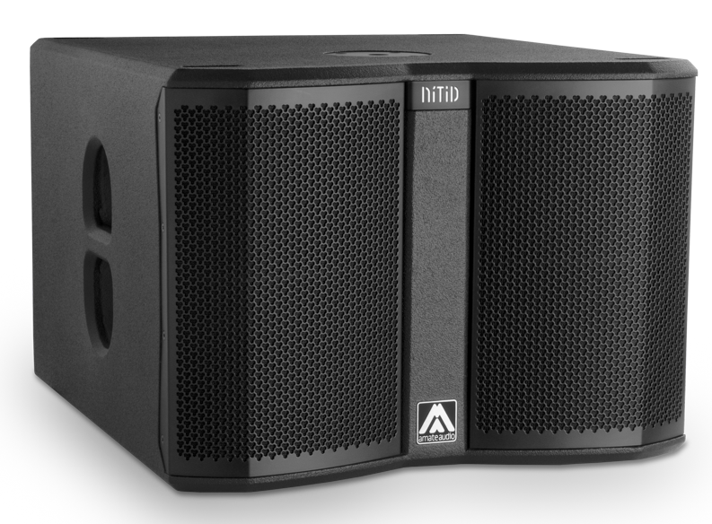


Architectural and engineering specifications

S12W

• The system shall consist of an active subwoofer enclosure. The enclosure shall feature a 3-inch voice coil, ferrite magnet, 12-inch loudspeaker component, loaded in a band-pass tuned enclosure. Low frequency transducer shall be rated at a nominal impedance of 8 ohms.

• The usable bandwidth shall be 38Hz to 130Hz (-10dB).

• Maximum SPL continuous, measured at 1m under free field conditions shall be 126 dB. Maximum SPL peak, measured at 1m under free field conditions shall be 129 dB.

• Enclosure shall be band-pass type with lateral laminar ports.

• Enclosure cabinet construction shall consist of birch plywood. Dimensions shall be 520 mm (20,5 inch) wide, 384 mm (15,1 inch) high, 582 mm (22,9 inch) deep. Enclosure weight shall be 26.7 Kg.

• Enclosure cabinet finish shall consist of black matt high-resistance Polyurea® paint.

• The front enclosure shall be protected by two 1.5mm steel grilles with acoustically transparent black technical mesh. The grille shall be secured via screws to keep it in place when facing the cabinet downwards.

• The cabinet shall feature a round socket with M20 thread located on the top panel to allow full-range enclosure coupling.

• The amplifier shall be built inside the cabinet, consisting of one channel, with a total power of 1000W/8Ohm. The amplifier shall be 3rd Generation Class D.
• The amplifier’s power supply shall be switching mode equipped with Power Factor Correction and accept a universal input voltage (85 to 265 VAC). The power supply shall protect itself in case of excessive voltage at the mains and rearm itself when the voltage is in the specified range. Mains supply shall be through PowerCon, and a PowerCon Link connector shall be available.

• The analogue audio input shall be electronically balanced, with a minimum input impedance of 50kOhm. Connectors shall be XLR type (one female for input and one male for linking). The nominal input shall be of +2dBu, and the input shall accept up to +20dBu without distortion.

• The system shall be equipped with an in-built digital signal processor (DSP), integrated to the power amplifier. The internal DSP architecture shall be 64-bit double precision, featuring IIR and FIR filters. Analogue-to-Digital converters shall have a signal-to-noise ratio better than 98dB, 24-bit word size and shall work at 48 kHz sampling rate.

• The DSP shall contain factory and the possibility of user-defined presets. The presets and the main DSP parameters such as gain, limiter threshold and delay shall be visible and selectable by the user at the cabinet’s rear panel via a built-in 3.5” TFT touchscreen. The available memory for the delay line shall allow up to 100m (294 milliseconds).

• The DSP board shall be equipped with an internal USB port for firmware update and maintenance purposes. The port shall be accessed by removing the amplifier from the cabinet. The connector used will be USB-C.

• The loudspeaker system shall be the Amate Audio® NITID S12W.

December 2022

