

Architectural and engineering specifications

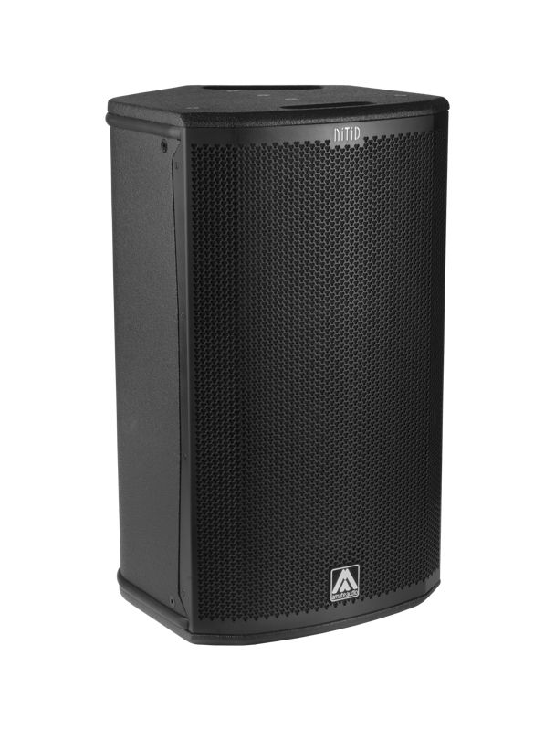
S12

• The 2-way full range active loudspeaker system shall have one direct radiating, 3-inch voice coil, 12-inch neodymium magnet low frequency transducer and one 1,5-inch voice coil diameter, polymer diaphragm neodymium magnet ring driver loaded onto an asymmetrical rotational horn. Low frequency transducer shall be rated at a nominal impedance of 4 ohms. High frequency transducer shall be rated at a nominal impedance of 16 ohms.

• The usable bandwidth shall be 52Hz to 19kHz (-10dB).

• The system’s horizontal coverage shall be 50º to 100º, with vertical coverage of 55º.

• Maximum SPL continuous, measured at 1m under free field conditions shall be 128 dB. Maximum SPL peak, measured at 1m under free field conditions shall be 131 dB.

• Enclosure shall be bass-reflex type with two half-round ducts.

• Enclosure cabinet construction shall consist of birch plywood. Dimensions shall be 360 mm (14,2 inch) wide, 623 mm (24,5 inch) high, 397 mm (15,4 inch) deep. Enclosure weight shall be 19,9 Kg.

• Enclosure cabinet finish shall consist of black matt high-resistance Polyurea® paint.

• The front enclosure shall be protected by a 1.5mm steel grille with acoustically transparent technical mesh. The grille shall be secured via screws to keep it in place when facing the cabinet downwards.
• The enclosure shall include M8 points and internal hardware for rigging and shall be used in conjunction with dedicated rigging accessories. Rigging accessories shall be affixed with special crop resistant screws.

• The cabinet shall feature a 35mm (1,38 inch) diameter pole mount socket mounted on the bottom side, for a standard tripod.

• The amplifier shall be built inside the cabinet, consisting of two channels, with a total power of 800W/4Ohm for the low frequency channel and 200W/16Ohm for the high frequency channel. The amplifier shall be 3rd Generation Class D.

• The amplifier’s power supply shall be switching mode equipped with Power Factor Correction and accept a universal input voltage (85 to 265 VAC). The power supply shall protect itself in case of excessive voltage at the mains and rearm itself when the voltage is in the specified range. Mains supply shall be through PowerCon, and a PowerCon Link connector shall be available.

• The analogue audio input shall be electronically balanced, with a minimum input impedance of 50kOhm. Connectors shall be XLR type (one female for input and one male for linking). The nominal input shall be of +8dBu, and the input shall accept up to +20dBu without distortion.

• The system shall be equipped with an in-built digital signal processor (DSP), integrated to the power amplifier. The internal DSP architecture shall be 64-bit double precision, featuring IIR and FIR filters. Analogue-to-Digital converters shall have a signal-to-noise ratio better than 98dB, 24-bit word size and shall work at 48 kHz sampling rate.

• The DSP shall contain factory and the possibility of user-defined presets. The presets and the main DSP parameters such as gain, limiter threshold and delay shall be visible and selectable by the user at the cabinet’s rear panel via a built-in 3.5” TFT touchscreen. The available memory for the delay line shall allow up to 100m (294 milliseconds).

• The DSP board shall be equipped with an internal USB port for firmware update and maintenance purposes. The port shall be accessed by removing the amplifier from the cabinet. The connector used will be USB-C.

• The loudspeaker system shall be the Amate Audio® NITID S12.
• The rigging accessories shall be the Amate Audio® ACR-M8, HR-LU, HR-LU/GT, U-BL, SP-WHR, RB-L, RB-L/GT.

April 2024

