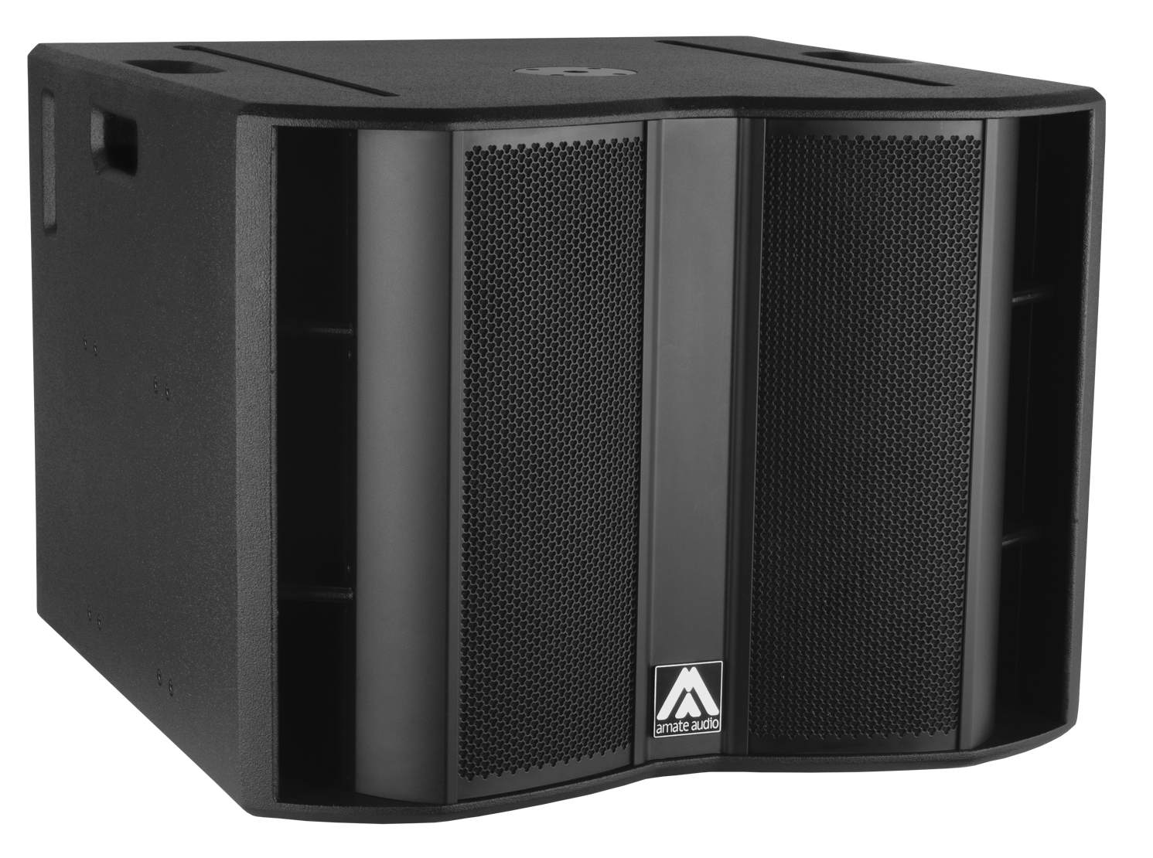


Architectural and engineering specifications

S18WP

• The system shall consist of a passive subwoofer enclosure. The enclosure shall feature a direct radiating 4-inch voice coil, neodymium magnet, 18-inch loudspeaker component, loaded in a bass-reflex tuned enclosure. Low frequency transducer shall be rated at a nominal impedance of 8 ohms.

• The usable bandwidth (using an external DSP) shall be 33Hz to 140Hz (-10dB).

• SPL, measured at 1W and 1m under free field conditions shall be 98 dB.

• Maximum SPL continuous, measured at 1m under free field conditions shall be 132 dB. Maximum SPL peak, measured at 1m under free field conditions shall be 135 dB.

• Continuous musical program shall be 2400W.

• Enclosure shall be bass-reflex type with lateral laminar ports.

• Enclosure cabinet construction shall consist of birch plywood. Dimensions shall be 740 mm (29.1 inch) wide, 555 mm (21.8 inch) high, 748 mm (29.4 inch) deep. Enclosure weight shall be 53 Kg.

• Enclosure cabinet finish shall consist of black matt high-resistance Polyurea® paint.

• The front enclosure shall be protected by two 2mm steel grilles with acoustically transparent black technical mesh. The grille shall be secured via screws to keep it in place when facing the cabinet downwards.

• The cabinet shall feature a round socket with M20 thread located on the top panel to allow full-range enclosure coupling.

• Electrical connections shall be made via one of the two 4-pole NL4MP Speakon connectors with the following configuration: +1/-1 signal input, +2/-2 disconnected

• The loudspeaker system shall be the Amate Audio® NITID S18WP.
• The rigging accessories shall be the Amate Audio® KRW118 and BRWX.

October 2024

