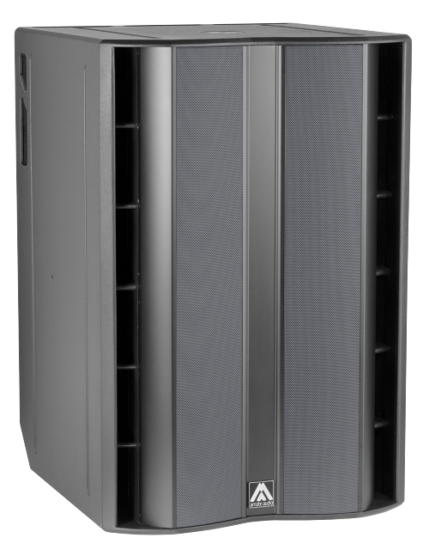


Architectural and engineering specifications

S218WP

• The system shall consist of a passive subwoofer enclosure. The enclosure shall feature two direct radiating 4-inch voice coil, ferrite magnet, 18-inch loudspeaker components, front loaded in a bass-reflex tuned enclosure. Low frequency transducers shall be rated at a nominal impedance of 8 ohm (each one), with a total impedance of 4 ohm.

• The usable bandwidth (using an external DSP) shall be 30Hz to 130Hz (-10dB).

• SPL, measured at 1W and 1m under free field conditions shall be 102 dB.

• Maximum SPL continuous, measured at 1m under free field conditions shall be 139 dB. Maximum SPL peak, measured at 1m under free field conditions shall be 142 dB.

• Continuous musical program shall be 4800W.

• Enclosure shall be bass-reflex type with lateral laminar ports.

• Enclosure cabinet construction shall consist of birch plywood. Dimensions shall be 750 mm (29,5 inch) wide, 1116 mm (43,9 inch) high, 780 mm (30,7 inch) deep. Enclosure weight shall be 102 Kg.

• Enclosure cabinet finish shall consist of black matt high-resistance Polyurea® paint.

• The front enclosure shall be protected by two 2mm steel grilles with acoustically transparent black technical mesh. The grille shall be secured via screws to keep it in place when facing the cabinet downwards.

• The cabinet shall feature a round socket with M20 thread located on the top panel to allow full-range enclosure coupling.

• Electrical connections shall be made via a 4-pole NL4MP Speakon connector with the following configuration: +1/-1 signal input, +2/-2 disconnected

• The loudspeaker system shall be the Amate Audio® NITID S218WP.

November 2024

