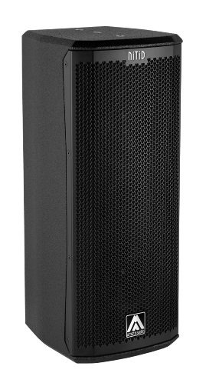


Architectural and engineering specifications

S26P

• The 2-way full range passive loudspeaker system shall have two direct radiating neodymium magnet, 1.5-inch voice coil, 6-inch low frequency transducers and one 1-inch voice coil diameter, PEN diaphragm neodymium magnet compression driver loaded onto a horn. Low frequency transducers shall be rated at a nominal impedance of 8 ohm (each single speaker) for S26P/16 model and at a nominal impedance of 16 ohm (each single speaker) for S26P/8 model. High frequency transducer shall be rated at a nominal impedance of 8 ohm.

• The usable bandwidth shall be 62Hz to 20kHz (-10dB).

• The system’s horizontal coverage shall be 70º, with vertical coverage of 70º.

• SPL, measured at 1W and 1m under free field conditions shall be 95dB. Maximum SPL continuous, measured at 1m under free field conditions shall be 121 dB. Maximum SPL peak, measured at 1m under free field conditions shall be 124 dB.

• Maximum continuous musical program shall be 400W.

• Enclosure shall be bass-reflex type with two half-round ducts.

• Enclosure cabinet construction shall consist of birch plywood. Dimensions shall be 230 mm (9,05 inch) wide, 572 mm (22,5 inch) high, 250 mm (9,84 inch) deep. Enclosure weight shall be 9,3 Kg.

• Enclosure cabinet finish shall consist of black matt high-resistance Polyurea® paint.
• The front enclosure shall be protected by a 1.5mm steel grille with acoustically transparent technical mesh. The grille shall be secured via screws to keep it in place when facing the cabinet downwards.

• The enclosure shall include M8 points and internal hardware for rigging and shall be used in conjunction with dedicated rigging accessories. Rigging accessories shall be affixed with special crop resistant screws.

• The cabinet shall feature a 35mm (1,38 inch) diameter pole mount socket mounted on the bottom side, for a standard tripod.

• Electrical connections shall be made via one of the two 4-pole NL4MP Speakon connectors with the following configuration: +1/-1 signal input, +2/-2 disconnected.

• The system shall include an internal passive crossover.

• The loudspeaker system shall be the Amate Audio® NITID S26P.
• The rigging accessories shall be the Amate Audio® ACR-M8, HR-LU, HR-LU/GT, UB-L, SP-WHR, SP-6N, SP-S26, RB-S, RB-S/GT.

April 2024

