
Architectural and engineering specifications

X102FD
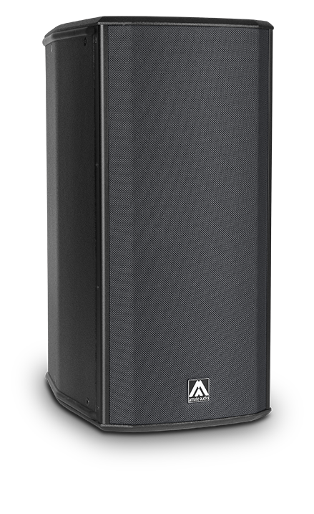
• The system shall consist of a 2-way full range active enclosure. The low frequency transducers should feature two 2-inch long excursion voice coil, 10-inch neodymium magnet loudspeakers loaded to two mid phase plugs and the high frequency transducer shall feature one 3-inch titanium diaphragm neodymium magnet driver loaded to a rotatable horn. Low frequency transducers shall be rated at a nominal impedance of 16 ohms each one. High frequency transducer shall be rated at a nominal impedance of 8 ohms.

• The usable bandwidth shall be 58Hz to 19kHz (-10dB).

• The system’s horizontal coverage shall be 80º, with vertical coverage of 60º.

• Maximum SPL continuous, measured at 1m under free field conditions shall be 136 dB. Maximum SPL peak, measured at 1m under free field conditions shall be 139 dB.

• Enclosure shall be bass-reflex type.

• Enclosure cabinet construction shall consist of Baltic birch plywood. Dimensions shall be 330 mm (13 inch) wide, 704 mm (27,7 inch) high, 460 mm (18,1 inch) deep. Enclosure weight shall be 28 Kg.

• Enclosure cabinet finish shall consist of black matt high-resistance Polyurea® paint.

• The front enclosure shall be protected by a 1.5mm steel grille with acoustically transparent grey cloth.

• The cabinet shall feature a 35mm (1,38 inch) diameter pole mount socket mounted on the bottom side, for a standard tripod.

• The enclosure shall include internal hardware for rigging and shall be used in conjunction with dedicated rigging accessories. Rigging accessories shall be made of stainless steel and must be affixed with special crop resistant screws.

- The amplifier shall be built inside the cabinet, consisting of two channels, with a total dynamic power of 2500W/4 Ohm for the low frequency channel and 500W/8 Ohm for the high frequency channel. The amplifier shall be 3rd generation Class D.

• The amplifier’s power supply shall be switching mode equipped with Power Factor Correction and accept a universal input voltage (85 to 265 VAC). The power supply shall protect itself in case of excessive voltage at the mains and rearm itself when the voltage is in the specified range. Mains supply shall be through PowerCon, and a PowerCon Link connector shall be available.

• The analogue audio input shall be electronically balanced with a 20kOhm impedance. Connectors shall be XLR type (one female for input and one male for linking). The nominal input shall be of +8dBu, and the input shall accept up to +20dBu without distortion.

• The audio networking input shall operate via the Ethernet RJ45 ports at 1Gbps using Dante™ audio netwoking. It shall manage 1 channel at 48kHz sampling frequency.The system shall be able to connect with other Dante-enabled products over an Ethernet-based network.

• The DSP controller shall be built inside the cabinet and integrated to the power amplifier. The internal DSP architecture shall be 64-bit fixed point, featuring IIR and FIR filters. Analog-to-Digital converters shall have more than 112dB signal-to-noise ratio, 24-bit word size and shall work at 48kHz sampling rate. The controller shall contain factory and user-defined presets. The presets shall be visible and selectable by the user at the cabinet’s rear panel (with built-in touchscreen). The available memory for delay shall allow up to 100m delay (294 milliseconds).
• The control and monitoring protocol shall operate at 1Gbps with wired connection and shall be compatible with Dante audio networking, sharing the same network. The connection shall be made through two switched RJ45 ports at the cabinet rear panel, allowing daisy-chained connection to other elements. The maximum recommended number of daisy-chained devices shall not exceed 8 when using Dante audio networking.

• The control and monitoring software shall be capable of monitoring the following parameters: input level, output level, clip limiter activation, amplifier temperature and network connection status. The software shall be capable of selecting different EQ presets for each cabinet, as well as adding EQ or filters, and controlling gain, mute, delay and polarity.

• The loudspeaker system shall be the Amate Audio® Xcellence X102FD.
• The rigging accessories shall be the Amate Audio® Xcellence HR-L102, HR-L, HR-L/GT, SP-WHR, RB-L, RB-L/GT, RB-L1082 or ACR-M8.
• The DSP control software should be the Amate Audio® DSPStudio3 or DSPStudio4.
• The audio networking control software should be Audinate® Dante™ Controller

Audinate® is a registered trademark of Audinate Pty Ltd.
Dante™ is a trademark of Audinate Pty Ltd.

December 2024

