
Architectural and engineering specifications

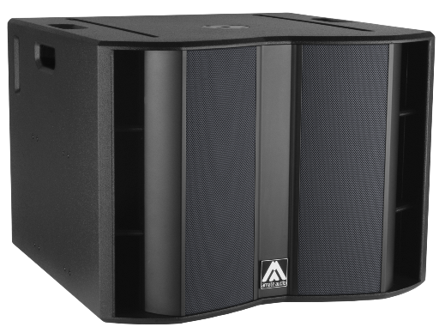
XW118

• The system shall consist of an active subwoofer enclosure. The enclosure shall feature a direct radiating 4-inch voice coil, neodymium magnet, 18-inch low frequency transducer. Low frequency transducer shall be rated at a nominal impedance of 4 ohm.

• The usable bandwidth shall be 30 Hz to 140 Hz (-10 dB).

• Maximum SPL continuous, measured at 1m under free field conditions shall be 133 dB. Maximum SPL peak, measured at 1m under free field conditions shall be 136 dB.

• Enclosure shall be band-pass type with lateral laminar ports.

• Enclosure cabinet construction shall consist of birch plywood. Dimensions shall be 740 mm (29.1 inch), 555 mm (21.8 inch) high, 748 mm (29.4 inch) deep. Enclosure weight shall be 56.8 Kg.

• Enclosure cabinet finish shall consist of black matt high-resistance Polyurea® paint.

• The front enclosure shall be protected by two 2mm steel grilles with acoustically transparent grey micro-foam cloth. The grille shall be secured via screws to keep it in place when facing the cabinet downwards.

• The cabinet shall feature a round socket with M20 thread located on the top panel to allow full-range enclosure coupling.

• The cabinet shall feature several M6 rigging points to fix an external rigging hardware.

• The amplifier shall be built inside the cabinet, consisting of one channel, with a total power of 2500W/4Ohm. The amplifier shall be 3rd Generation Class D.

• The amplifier’s power supply shall be switching mode equipped with Power Factor Correction and accept a universal input voltage (85 to 265VAC). The power supply shall protect itself in case of excessive voltage at the mains and rearm itself when the voltage is in the specified range. Mains supply shall be through PowerCon, and a PowerCon Link connector shall be available.

• The analog audio input shall be electronically balanced with a 20kOhm impedance. Connectors shall be XLR type (one female for input and one male for linking). The nominal input shall be of +2dBu, and the input shall accept up to +20dBu without distortion.

• The audio networking input shall operate via the Ethernet RJ45 ports at 1Gbps using Dante™ audio netwoking. It shall manage 1 channel at 48kHz sampling frequency.The system shall be able to connect with other Dante-enabled products over an Ethernet-based network.

• The DSP controller shall be built inside the cabinet and integrated to the power amplifier. The internal DSP architecture shall be 64-bit fixed point, featuring IIR and FIR filters. Analog-to-Digital converters shall have more than 112dB signal-to-noise ratio, 24-bit word size and shall work at 48kHz sampling rate. The controller shall contain factory and user-defined presets. The presets shall be visible and selectable by the user at the cabinet’s rear panel (with built-in touchscreen). The available memory for delay shall allow up to 100m delay (294 milliseconds).

• The control and monitoring protocol shall operate at 1Gbps with wired connection and shall be compatible with Dante audio networking, sharing the same network. The connection shall be made through two switched RJ45 ports at the cabinet rear panel, allowing daisy-chained connection to other elements. The maximum recommended number of daisy-chained devices shall not exceed 8 when using Dante audio networking.

• The control and monitoring software shall be capable of monitoring the following parameters: input level, output level, clip limiter activation, amplifier temperature and network connection status. The software shall be capable of selecting different EQ presets for each cabinet, as well as adding EQ or filters, and controlling gain, mute, delay and polarity.

• The loudspeaker system shall be the Amate Audio® Xcellence XW118.
• The flying accessoris shall be the Amate Audio® KRW118 and BRWX.
• The stacking accessories shall be the Amate Audio® STAX.
• The DSP control software should be the Amate Audio® DSPStudio 3 or DSPStudio4.
• The audio networking control software should be Audinate® Dante™ Controller

Audinate® is a registered trademark of Audinate Pty Ltd.
Dante™ is a trademark of Audinate Pty Ltd.

December 2024

